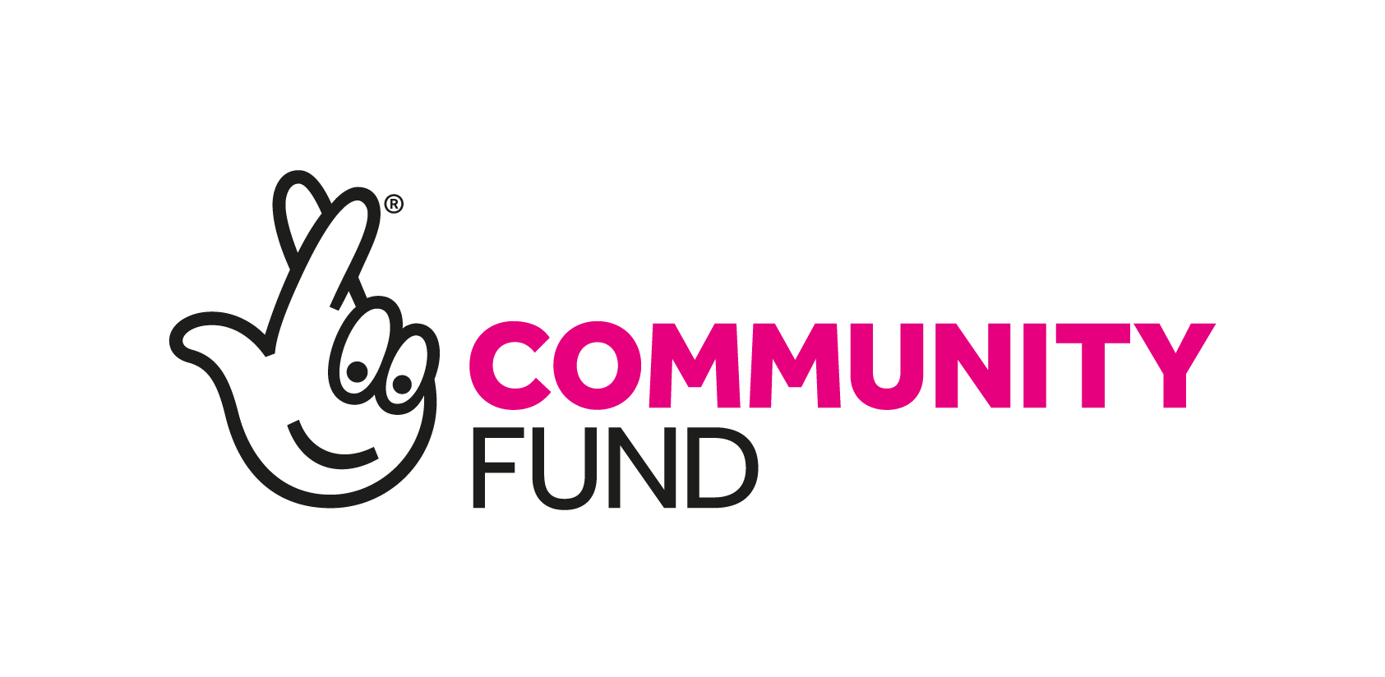
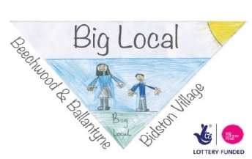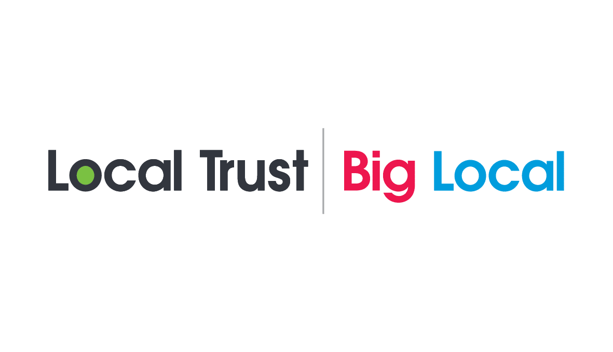

Beechwood, Ballantyne & Bidston Village Big Local Partnership

Invitation to Tender - Plan writer and facilitator

Contents

- Summary of Tender

- Background

- Specification

- Submission guidelines

- Terms and conditions

- Tender documents

- Evaluation Criteria

- Pricing Schedule

- Summary of Tender

Client: Beechwood, Ballantyne & Bidston Village Big Local Partnership

Description: To facilitate additional consultation and lead on the writing of the final Big Local Plan for the Beechwood, Ballantyne & Bidston Village Big Local area

Contract value: The anticipated value of the contract is open to organisations to cost out and submit, inclusive of VAT and all expenses.

Closing date for clarification questions: Friday 14th May 2021 – 5pm
Closing date for tender submissions: Friday 21st May 2021 – 12noon
Decision on winning tender shared: Friday 18th June 2021 – 5pm
Project start: The successful organisation should be available to start work no later than 5th July 2021
Main Consultation Period: 5th July 2021- 14th August 2021
Feedback to Partnership: 13th September 2021 - Outline of initial consultation results, indication of any key themes emerging.
Finishing School workshops, stakeholder conversations: 4th – 15th October 2021
First full draft presented to Partnership: 8th November 2021
Final plan presented for approval of Partnership: 13th December 2021

Contact: All enquiries and clarification questions should be made by email to Helene Storey

Address: Community Foundations for Lancashire & Merseyside

Email: helene.storey@cflm.email

- Background

The Big Local programme is a £200 million investment by the Big Lottery Fund to support 150 communities in England to make their area more resilient, confident and a good place to live. The programme is managed by Local Trust, an independent organisation that supports communities in each neighbourhood to develop their skills and confidence to identify what matters most to them and to take action to change things for the better, now and in the future. This community and resident led approach to improving their local area aims to build on the opportunities and assets within each community to create lasting long term solutions and make best use of the scarce resources that are available.

Each Big Local area has been awarded £1 million to be spent over a period of up to 10 years to bring about the long term sustainable changes that are important to their local community. For more information about Local Trust go to www.localtrust.org.uk

Beechwood, Ballantyne & Bidston Village (BBB) Big Local is based in Birkenhead, Wirral and is home to approximately 4,300 people. With support from Local Trust, residents carried out wide scale consultation with the local community in 2019 to identify the changes that local people want to see happen in the area. The BBB Big Local Partnership is the resident led body responsible for managing the Big Local Programme and, based on the views of the local community identified the priorities for change.

Every Big Local Partnership is guided by the four central Big Local outcomes of the National programme. The new Plan for BBB must be able to demonstrate how it contributes towards these Local Trust outcomes.
- Communities will be better able to identify local needs and take action in response to them.
- People will have increased skills and confidence, so that they continue to identify and respond to needs in the future.
- The community will make a difference to the needs it prioritises.
- People will feel that their area is an even better place to live.

Beechwood, Ballantyne & Bidston Village Big Local Partnership:

The BBB Big Local Partnership now needs to produce a new plan for the last 3 years (April 2022 to March 2025). The Plan needs to be detailed with costings to demonstrate that the remaining Big Local funding will be spent by the end of the programme.

Existing Plan Themes:

- Health and wellbeing
- Community spaces
- Education and learning
- Financial and digital inclusion
- Social investment and community business

Copy of our current plan is attached.

Community Foundations for Lancashire & Merseyside has been appointed as the Locally Trusted Organisation to hold and administer Big Local funds and manage contracts on Beechwood, Ballatnyne & Bidston village Big Local Partnership’s behalf.

The first plan covered 2 years and was approved in 2014, and this was followed by a 3 year plan which expired in November 2019. The current plan is for two years and runs until March 2022. The Partnership now needs to enter the process of writing a new plan for years 8-10 (March 2022- March 2025).

- Specification:

The successful tenderer will be required to create the new, revised Big Local Plan for Beechwood, Ballantyne & Bidston village by:
- Meeting the guidelines set out in the Local Trust’s Big Local Plan document (to be provided by Community Foundations for Lancashire & Merseyside) specifically noting the Plan should have three parts
  - The Costed Vision (to show how the full £1million will be spent by the end of the programme)
  - The Action Plan (it is important the Action Plan fits with the Costed Vision)
  - Legacy Statement (this will be provided by the Partnership)
- Being familiar with previous consultations and interpreting the results to offer potential solutions into the plan. (to be provided by Community Foundations for Lancashire & Merseyside)
- Being aware of the deprivation indices for Beechwood, Ballantyne & Bidston Village to understand the local context.
- Leading on gathering the views from a wide range of people in the community, this needs to include:
- Working with the Partnership;
  - Specific workshop(s) to present progress including feedback from consultation sessions and to use these to help the Partnership clarify their future costed vision and plan priorities.
  - Identify sustainability options including social investment solutions for core projects.
  - Stakeholder consultations; BBB groups, local businesses, local community, Police, Housing and the local Councillors and Wirral Borough Council. (Contact details to be provided by Community Foundations for Lancashire & Merseyside).
- Facilitating workshops / consultation sessions with existing community and voluntary sector groups and public sector partners, including; The Little Centre, Bee Wirral, Onward Housing and Tranmere Rovers in the Community.
- Engaging young people. BBB will require at least one youth focused consultation aimed at High School age pupils and three with Primary School age pupils. (Big Local will contact local High Schools and Primary Schools to request that pupils attend these sessions).
- Facilitating informal Drop-in sessions in the community.
- Offering a final ‘mop up sessions’ to engage interested parties that couldn’t make earlier sessions, at the discretion of the Partnership.
- Taking the priorities already identified in the current plan and checking with residents that they are still relevant and if so, building them into a new revised plan to deliver sustainable change.
- Challenging residents and the Partnership to think about ‘Year 11’ to devise social investment solutions to priorities to ensure they continue post Big Local.
- Consulting on any additional or newly emerging priorities and checking their relevance to the new revised plan e.g. food poverty and holiday hunger
- Identifying any collective interests that may arise. e.g. ‘Men in Sheds’, gaming, families with children with special educational needs etc.
- Include full staffing costs
- Office Space and Room Hire Costs
The Partnership would expect all workshops to be fully staffed by the successful organisation and demonstrate innovative and creative ways to engage local people (particularly in light of Covid-19 and social distancing restrictions). The Partnership will help promote and advertise all sessions. Big Local volunteers/ workers will aim to support where appropriate e.g. opening and closing venues if required, providing refreshments etc.

- Attendance if requested at the meeting with a Local Trust plan assessor.

  - Submission guidelines:

Please include all of the following in your submission.
- Background information on your organisation and the resources and expertise you have available to you.
- Details of relevant insurance held.
- Details of your proposed approach and methodology. Include a breakdown of workshops and engagement sessions you intend to deliver.
- Information on the team that would deliver the consultation and plan writing including summary CVs detailing their specific experience and qualifications.
- Details of any sub-contracted third parties you would be using.
- A proposed timeline of activity and an outline project plan.
- A breakdown of your total costs to complete the project including VAT and expenses and why you feel this represents value for money.
- The contact details of two referees for whom you have completed similar work.
- Any added value your organisation would deliver in carrying out this work.

  - Terms and conditions:

- This Invitation to Tender is not an offer to enter into an agreement with you. It is a request to receive proposals from organisations that are interested in delivering this project.
- Any points of clarification about this Invitation to Tender must be made by the date specified in Section 1 (Summary of tender) to the email address of the contact person specified in Section 1.
- Beechwood, Ballantyne & Bidston village Big Local Partnership reserves the right, at its sole discretion, to accept or reject any tender and does not bind itself to accept the lowest price or any tender. It or Community Foundations for Lancashire & Merseyside shall not be liable for any costs or expenses incurred by bidders in preparing and submitting a response to this Invitation to Tender.
- Tenders will be evaluated against the criteria set out in section 7.
- The preferred bidder will not be permitted to enter into negotiations on the terms of the Contract. Any attempt to negotiate amendments will breach the terms of this Invitation to Tender and will result in the preferred bidder being excluded from the tender process.

  - Tender documents:

- Tenders, all associated documents and correspondence must be written in English.
- All pages of the tender must be numbered sequentially.
- It is the bidder’s responsibility to ensure that all of the information required is supplied. Unless the bidder provides all of the information required the tender will be rejected.
- Tenders must be submitted by email to the contact person specified in Section 1 (Summary of Tender) before 12 noon on the date specified in Section 1.

  - Evaluation Criteria:

Tender submissions will be evaluated against the following criteria.

Criteria | Weighting
Quality of the proposal demonstrating a clear understanding of the brief and the outcomes we want from this work. | 25%
The proposal’s value for money and inclusion of a realistic timeline and budget. | 25%
Credibility and proven relevant experience of the organisation and the staff that will be assigned to carrying out this work. | 20%
Ability to work effectively with Beechwood, Ballantyne & Bidston Village Local Partnership and local residents. | 20%
Any added value offered by the bidder. | 10%
Total | 100%

  - Pricing Schedule:

The anticipated value of the contract is open to organisations to cost out and submit, inclusive of VAT and all expenses.

An upfront payment of 50% of the contract value will be made upon signing the contract. The second and final payment will be paid upon the Partnership accepting the final written plan.

